Vehicular Crossing – general guidance
Please return the completed form to: Slough Borough Council, Highways Engineering,
St. Martins Place, 51 Bath Road, Slough SL1 3UF

Definition
The vehicular crossing is the sloped area of footway between the kerb edge and your front garden.

Description
The maximum width of a vehicular crossing is 4 yards (3.66 metres not including splays) wide (see Figure 1). A maximum of one crossing per household, no more than two adjacent crossings without a 5 metre length of full height kerb.
Other details
Objects such as lamp posts, street furniture, gas, electricity, water boxes and apparatus on the proposed crossing will need to be moved at your expense (see Figure 5 Vehicular Crossing Rates Table on page 5 for details). You will also be required to pay for the cost of moving/ removing any parking bays/ restrictions (see Parking on page 3 for details).
If your car is parked on your hard standing (see page 3) it must not project beyond the highway boundary (i.e. where your garden meets the footway) and cause obstruction.
A vehicular crossing is not allowed within 5 metres of a junction (see page 3) or the zigzags of a pedestrian crossing.
If the kerb outside your house is not dropped it is illegal to drive over it to gain access to your front garden/hard standing.
Slough Borough Council require residents to maintain an access to their front doors even if there is a car parked in their front garden (see Figure 2) and permissions will be based on this requirement.
NB – although the minimum length of required frontage is indicated as 4.8m in Figure 2, this length can be subject to reduction based on various factors. If this is the case there will be numerous stages to the process. Firstly, the highways inspector will recommend that the shorter frontage be allowed. This recommendation will then be reviewed by the supervising engineer. If required the head of section will also be involved in the final decision.
The width of the crossing will be granted in accordance to each specific location and will not exceed the maximum.
Slough Borough Council standard vehicular crossing construction is a 1 metre strip along the kerb edge of the footway. Where the gradient of the crossover exceeds 1:12 the Council will deem necessary that the crossing requires an additional area to be constructed; all costs will be highlighted in a quote.
On application the location will be assessed to establish whether the crossing will be on Housing land. If the crossing is on Housing land the applicant must contact Slough Borough Council Asset Management to request easement/licence; the cost for easement/licence will be paid by the applicant.

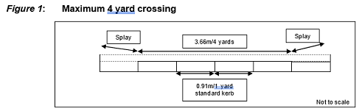

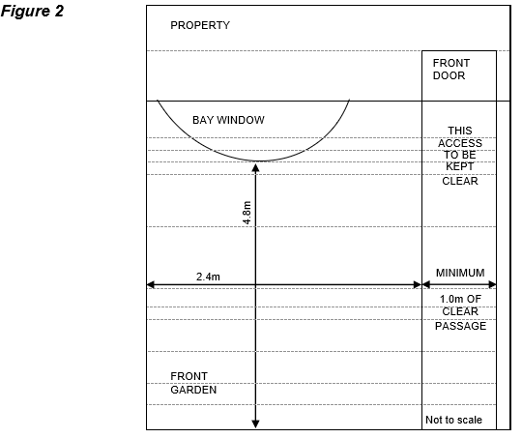

NB – although the minimum length of required frontage is indicated as 4.8m in Figure 2, this length can be subject to reduction based on various factors. If this is the case there will be numerous stages to the process. Firstly, the highways inspector will recommend that the shorter frontage be allowed. This recommendation will then be reviewed by the supervising engineer. If required the head of section will also be involved in the final decision.

Vehicular crossing works are not permitted to be carried out by any contractor other than Slough Borough Council’s approved term maintenance contractor, Slough Amey, because of public safety concerns and legal requirements for working on the public highway. Applicants will be charged the quoted cost based upon the contractor’s schedule of rates and prices.
The crossing, when constructed, does not become your property, it forms part of the public highway and will be maintained by the Council under the normal maintenance programme and may be subject to the relevant Traffic Regulation Order i.e. yellow lines.
The crossing only serves to provide access to and from your property; it does not reserve a parking space on the public highway for you. Also roads with a hammerhead turning area should be kept clear of any parked vehicles.
The crossing should not be used as a parking space. It is an access way into your hard standing (see hard standing definition).
Location of the crossing should not interfere with the existing visibility splays at road junctions (see Vehicular Crossings at Junctions on page 3).
In instances of obstruction only the Police can take action against offending motorists at the time when the crossing is actually required for use. Slough Borough Council can only enforce parking restrictions in roads where waiting restrictions (yellow lines) are in place.
If the proposed access is to serve a development for which consent has been given under the Town & Country Planning Acts, reference should be made to the planning consent number and any conditions attached to such consent, particularly in respect of visibility requirements for the layout.
Please be aware that if an unauthorised contractor is employed to undertake these works, the work will be in contravention of the Highways Act 1980 and deemed illegal. In this instance any costs incurred by the Highway Authority to rectify these illegal works will be charged to you. Also, if any damage is caused to utility apparatus or if an accident occurs on the damaged pavement, you may be liable to pay compensatio

Hard standing

Definition
A hard standing is the part of your front garden on which your car is parked.

Description
No surface water (usually rain water) is allowed to flow from your hard standing onto the public footway outside your house. In order to achieve this, the hard standing will need to be sloped towards your property. We advise you to install appropriate drainage at the end of the hard standing so any surface water can flow into it. The hard standing needs to be a minimum 4.8 metres deep and 2.4 metres wide in area (see Figure 2).
If the new front garden surface to be covered is more than five square metres planning permission will be needed for laying traditional, impermeable driveways that do not provide for the water to run to a permeable area. Planning permission is not required for porous materials like gravel.
- Impermeable surfaces may discharge onto a permeable area not less than 25% of the paved area.
- Soakaways require a minimum void volume (m3) of 0.013 x area drained (m2).
New hard standing front gardens that do not comply with planning will not be granted a vehicular crossing
Where the property frontage slopes towards the public highway adequate drainage provision must be provided together with a ‘water bar’ at least 50mm high to prevent any water running onto the highway and provide a visible indication of the adequacy of drainage. Permeable paving is not effective on slopes exceeding 1:20
Gradients for the vehicle access and standing area within the property should preferably not exceed 1:12, with a maximum of 1:10 permissible. Where the gradient exceeds 1:12 the vertical profile must be demonstrated to provide adequate clearance for an average car.
NB: Your hard standing will need to comply with recently introduced planning laws which deal with porous material and drainage issues. For further information, please visit ACO water management Please call 01753 475111 for further details.
Highway Inspectors will check the drainage to ensure it is to an acceptable standard prior to the installation of your vehicular crossing.
Should your hard standing be constructed with loose material there will be a requirement for the resident to keep all loose material swept back from the public highway. Regular monitoring will be required. Where damage to the highway can be attributed to the over flow of loose material the Council will take steps to enforce action.

Council houses
Please be aware that if you are a council tenant you MUST obtain permission from your Housing Officer in writing to ensure that you can convert your garden into a driveway. Telephone no: 01753 475111 and follow the instructions given for further details.

Vehicular crossings at junctions
Vehicular crossings at junctions are usually refused as they can potentially cause obstruction to motorists’ line of sight (see Figure 3).

In the diagram above vehicle 1 is coming out of its drive at the same time as vehicle 2 is approaching the road junction nearby. The arrow shows vehicle 2’s sight line which has been blocked by vehicle 1.

On street parking/designated parking bays
Where a parking bay exists a crossing will only be allowed where 2 or more vehicles can be accommodated off street.
NB: If we approve a vehicular crossing for applicants who already benefit from a disabled on-street parking bay; the applicant will be charged for the removal of that bay.
Where the Council operates the Pavement Parking Policy there will be a relaxation on forecourt depth providing the minimum footway widths are adhered to.

Traffic calming measures/street furniture/Cycleway
The vehicular crossing should be located at least 1.0 metre from any street furniture e.g. benches, bollards and lamp-posts. If a crossing is requested near traffic calming measures e.g. speed bumps/tables, pedestrian crossings, these will only be moved following approval by the Traffic Section. Any additional cost incurred on relocation of any street furniture will be charged to the applicant.
Where a shared or segregated cycleway exists or is proposed, the applicant will require approval from the Traffic Section to accommodate the cycleway; the cost of the crossing may be increased

Grass verges
Generally where an application for a vehicular crossing is made for access across a verge that is greater than 3m in width or any other grassed highway amenity area, it will be refused.

Highway trees - Precautionary area:
This is the area that if excavated could damage a highway tree (shaded area in figure 4). It is defined as 4 times the girth (the distance around an object; circumference) of the tree. If a vehicular crossing application is made and the crossing is requested near a highway tree, the impact of the crossing on the tree must be considered.
In the first instance you should try to find an alternative location for the crossing. If this is not possible then the council will need to get a tree specialist to assess the condition of the tree.
Dependant on the tree specialist’s findings and further consideration, the tree may be removed and/or replaced with a new semi mature tree at the cost of the applicant at another location. This is in accordance with our policy Approved Trees for the Highway.
If permission to remove the tree is not given you can still request trial holes to be dug. These will asses how far the tree roots actually encroach into the precautionary area. If installation of the crossing will not affect the tree roots, permission will be given. If it does your request will be refused. In either case you will need to pay for the cost of taking the trial holes.

Figure 4:
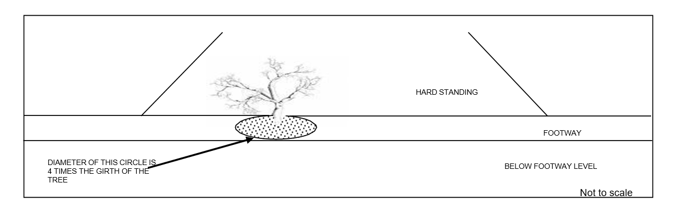

Refused applications

Applicants will be informed in writing of the reasons for refusal where applications do not confirm to the criteria.
In cases where previous policies have allowed residents to construct crossings but Council policy has changed, the current policy will always take precedence.
To appeal against a decision to refuse you a vehicular crossing, you can only do so if:
- the circumstances on site have changed from the time you made the initial application.
- you can show that the previous decision was incorrect.
The Council reserves the right to reject any application and the final decision is that of the Highways Department.

Financial information/method of payment
The preferred method of payment is a cheque made payable to Slough Borough Council. Payment cannot be made by card or cash.
Charges for the processing of vehicular crossing applications are reviewed annually. If planning permission (see page 6) is not required you are required to send a completed form and a cheque for the initial review fee of £65 to the Council (cheque made payable to Slough Borough Council).
NB: This fee is completely independent and will only cover the costs associated with the initial review of your application and providing you with an estimate. It does not cover any of the costs associated with actually installing your vehicular crossing.
The fee is non-returnable, regardless of whether the application is approved or rejected.
Work should commence on site approximately four to six weeks after receipt of FULL payment and also after receiving confirmation that you have an appropriate hard standing.
NB: The cost given below is only a general guidance and is valid until end of March 2017. The cost increases annually in line with the construction price index.
If we approve your application we will send you a quote for the costs of works by post.

Figure 5: Vehicular crossing rates table (the rate within the table is valid from 1st April 2017- 1st December 2017)
Type of work | Cost of work | Total cost (including admin. Fee)
Maximum 4 yard crossing | £750.59 | £860.59 (Including £45 Admin and  £65 inspection)
Moving utility companies’ surface boxes etc. | Dependant on utility companies’ rates.  NB: each company charges a fee for inspections which is required to be paid before the estimate can be sent. | £2,250 (approx guide).
Moving a lamp column | Dependant on the type of column, the cost will vary. | Up to £1500
Housing Land Easement/Licence | Dependant on Asset Management assessment | Up to £3000

Planning permission
Planning permission will be needed if:
The crossing is on a classified road (see list opposite).
The crossing is in a conservation area (see
Local Plan for Slough - Appendix 4).
The building that the crossing is for is a listed building (see Local Plan for Slough - Appendix 5 and 6).
Access the Local Plan for Slough
If you do need planning permission you will have to apply for it via the Planning Section tel. 01753 475111 for further details or visit government website planning portal
If planning permission is approved you have to submit a copy of the Decision Notice of approval with your vehicular crossing application.
NB: If you apply for a vehicular crossing before attaining planning permission you will lose the initial review fee of £65 if permission is refused.

Legal restrictions
Applicants should check their lease to ensure that no clause exists that forbids the parking of a vehicle in their front garden. Slough Borough Council will not accept responsibility if such a crossing is constructed.

Classified Roads requiring planning permission
A Roads Albert Street
Bath Road (Slough) Colnbrook By Pass
Farnham Road
London Road
Mere Road
Slough Road
Sussex Place
Tuns Lane
Uxbridge Road Wellington Street William Street Windsor Road
Yew Tree Road
B Roads Bath Road (Colnbrook)
Bridge Street Datchet Road
High Street (Colnbrook) High Street (Langley) Ledgers Road
Majors Farm Road Montem Lane
Park Street Colnbrook) Ragstone Road
Station Road (Langley) Stoke Road
Sutton Lane
NB: Although properties located along the majority of the above roads will require planning permission some properties may not For further details please call 01753 475111 and follow the instructions given.

Properties on the service roads of the above classified roads do not require planning permission.

