On Thursday 25 May 2023 the Licensing Team as the responsible authority in accordance with the published policy are to formally consult with members of the public, residents, business and other council partners.
PUBLIC NOTICE
Local Authorities (Miscellaneous Provisions) Act 1982 Schedule 4
Application for Street Trading Consent for an Outdoor Market on
Slough High Street
Location: From Mackenzie Square to Junction with Alpha Street North

The application is for an Outdoor Market to trade on Thursdays to Sundays from 6am to 6pm. Valid for one year once granted.
The location of the stalls are marked on the plan on page two of this notice.

Responses to this consultation are to be received no later than 16:00 on 23 June 2023

Any representations or objections can be registered with Slough Borough Council’s Licensing team by the following methods.
- By scanning the QR Code
- In writing to Licensing, Slough Borough Council, Observatory House, 25 Windsor Road, Slough SL1 2EL
- By email to licensing@slough.gov.uk
For details of our privacy policy visit www.slough.gov.uk/yourprivacy

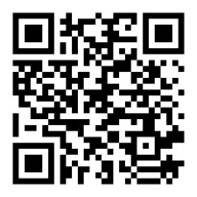
Scan QR Code to respond.

www.slough.gov.uk/business-licensing

If objections or representations are received to the application the matter will be referred to a Licensing Sub Committee for determination with a hearing to take place normally between 4 to 8 weeks from the end of the consultation period.

The Licensing Sub Committee is made up of local Councillors who will determine each application on its own individual merits. At the Committee hearing the applicant(s) and objectors will be given the opportunity to put their case forward. The Committee are empowered to grant, refuse, or apply any relevant conditions in addition to the General Conditions to any licence application put before them.

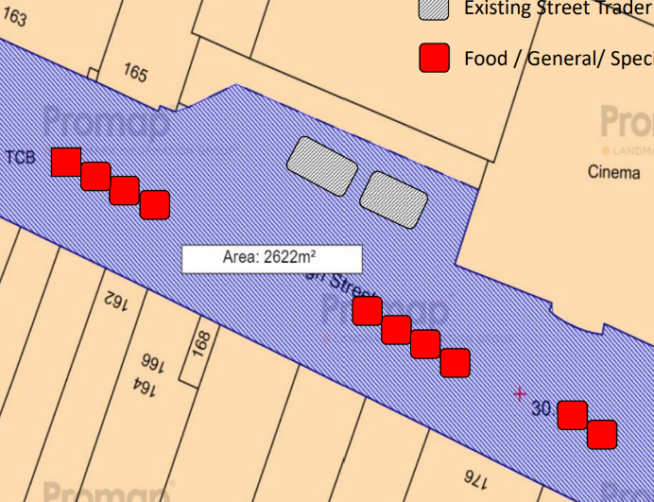
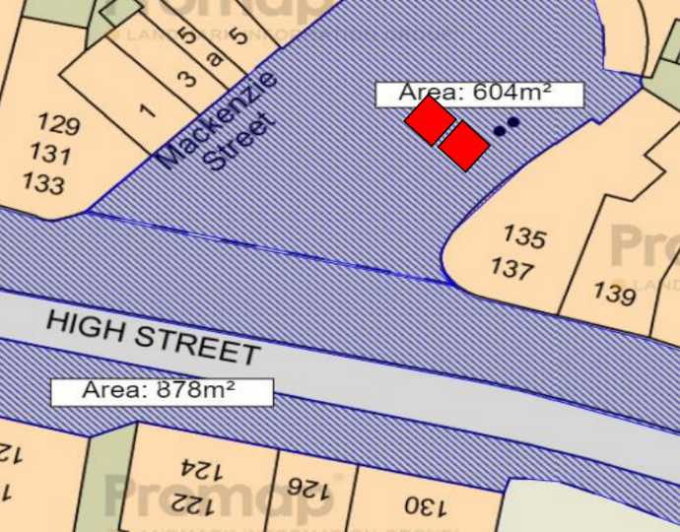
Zone 2 – O2 Shop to Queensmere (10)
Zone 1 – Mackenzie Square (2)
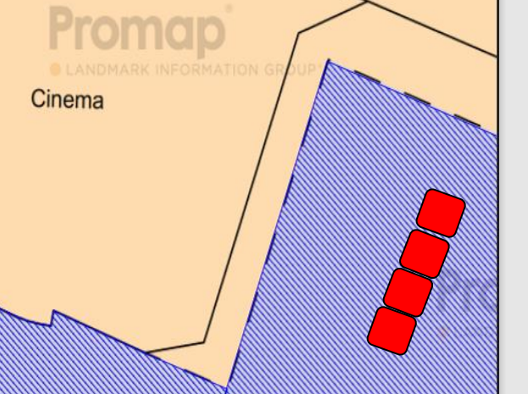
Zone 3 - Town Square (4)
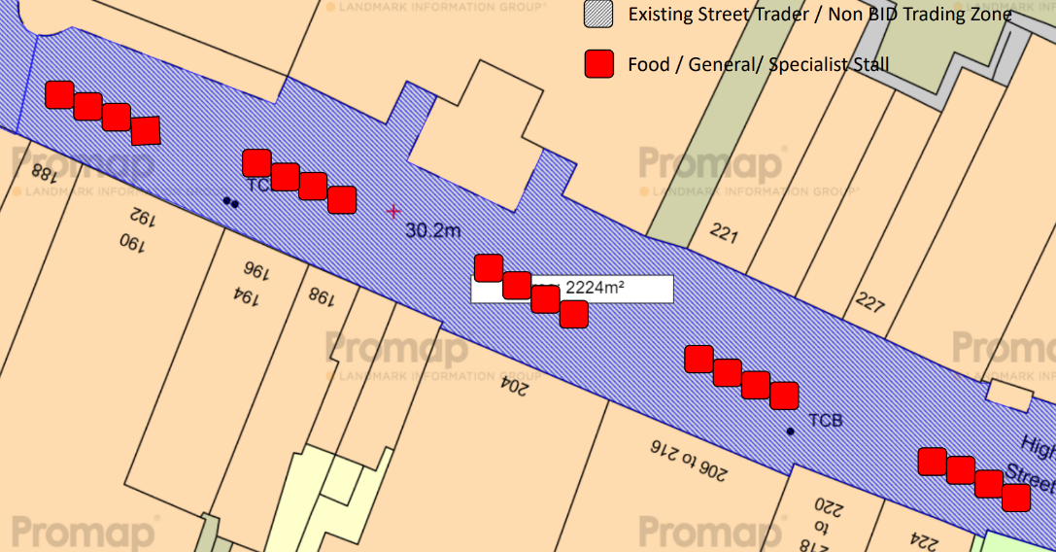
Zone 4 - Queensmere to Alpha St North (20)
NOTE: PLANS ARE NOT TO SCALE ON THIS NOTICE
Copyright of the maps is with the applicant.

